

**ONLINE TALENT EXPRESSION AND MARKETING SYSTEM FOR CREATIVE LITERATURE COMPOSERS REPORT**

**REPORT SUBMITTED IN PARTIAL FULFILMENT OF THE**

**REQUIREMENT FOR DIPLOMA IN IT**

**BY**

**DIT-01-0341/2022**

**FIDELIS KARANJA**

**TO**

**THE DEPARTMENT OF INFORMATION TECHNOLOGY**

**FACULTY OF SCIENCE AND ENGINEERING**

**ZETECH UNIVERSITY**

**DECEMBER 2022**

**DECLARATION**

I hereby declare that the project work ONLINE TALENT AND MARKETING FOR CREATIVE LITERATURE COMPOSERS is my work and the record of my own work.

Signature ………………………………… Date……………………………..

This proposal has been submitted for examination with my approval as the unit lecturer.

…………………………………. ………………………………

Signature Date

DEDICATION

This work is dedicated to God Almighty, my strong pillar, my source of inspiration, wisdom,

Knowledge and understanding. He has been the source of my strength throughout this program.

This work is also dedicated to my parents and my lecturers.

Thank you, my love for you all can never be quantified. God bless you.

**ACKNOWLEGEMENT**

I would like to thank the almighty God for His protection during the entire work. I also acknowledge the entire school and my supervisor for his guide during the project.

I express my sincere gratitude to the university HOD MR Daniel Njeru for providing an opportunity to work on a real time project.

I would also thank my parents for their continuous support that plays an important role in the completion of this project.

**ABSTRACT**

Online Talent Expression and Marketing System (OTEMS) is a Web based application that works within a centralized network based on creative composers. This project report presents a review on the software program “Talent Expression &Marketing System” as should be used In Marketing System, a facility which is used to help young people express their talents and market off their talents and so many things. OTEMS system is built for managing and computerizing the marketing shows, Talent shows and computer entertainment program.. It maintains all kinds of talent expression entertainment and gives shows to people. In order to achieve the design. Structured Systems Analysis and Design Methodology (SSADM) was adopted. Questionnaires and interviews were used to collect primary data. In addition, JavaScript and bootstrap language was used for the front- end of the software while the back end was designed using MySQL and PHP. The software achieved is capable of improving the customer hand and relationship management. It is recommended that despite the present functionality of the designed software, an additional functionality such as the use of Games platform was introduced in the Talent and Marketing software to enhance the OTEMS features.

# 

TABLE OF CONTENTS

**CHAPTER ONE: RESEARCH INTRODUCTION** 6

**1.1** **Research problem** 6

**1.2** **Research Objectives** 6

**1.2.1** **General Objective** 6

**1.2.2** **Specific Objectives** 6

**1.3** **Background Information** 6

**1.4** **Study Justification** 6

**1.5** **Study Limitation** 6

**1.6** **Problem Scope** 6

**CHAPTER TWO: LITERATURE REVIEW** 6

**2.1 Introduction** 6

**2.2 Theoretical Review** 7

**CHAPTER THREE: SYSTEM METHODOLOGY AND DATA COLLECTION** 10

**3.1 Introduction** 10

**3.2 System Requirements Specification** 12

**3.2.1 Functional Requirements** 12

**3.2.2 Non Functional Requirements** 13

**3.3.1 Low Level Design** 14

**3.3.2 High Level Design** 16

**3.4 Implementation / Development** 18

**3.4.1 Language(s), Frameworks and Other Technical Requirements** 18

**3.4.2 Code Review Strategy** 18

**3.5 Testing** 23

**3.5.1 Functional Requirements Testing** 23

**3.5.2 Non-Functional Requirements Testing** 24

**CHAPTER FOUR: CONCLUSION AND RECOMMENDATIONS** 25

**4.1 CONCLUSION** 25

**4.2 RECOMMENDATIONS** 26

**CHAPTER FIVE: REFERENCES AND APPENDICES** 27

**5.1 REFERENCES** 27

# **CHAPTER ONE: RESEARCH INTRODUCTION**

## **Research problem**

The Online Talent Expression and Marketing System is a fast and secure software system.

The scope of this project is to provide good talent marketing and communication to composers getting and shows classes online. The current system can be a user-friendly system, which does not store data in the proper security and can easily track information and contains the operation of fast-recovery information, such as talent data, all talent features services details and includes many documents.

The system is using JS and CSS as a front end and MySQL as a database to implement a full stack system.

## **Research Objectives**

### **General Objective**

* To come up with an ideal software that could make all talent marketing features services easier.
* Enhance and boost businesses, composer’s demands and education.

### **Specific Objectives**

* To solve the manual composers services
* To enhance the application of talent expression and marketing system online
* To save time and effort manually.
* Enabling to check the types and availability of shows online.

## **Background Information**

Online Talent Expression and Marketing System is Simple, flexible and powerful for Creative Composers that want to show and market their talents online the easy shows Software is a web based management software for Creative Literature Composers. It is designed and developed to make Creative Talent Expressers Entertainment management efficient and effective. Broadly, it covers all management areas of computer entertainment and Marketing Talent. The software is very easy to use and affordable software that enables to use and entertain themselves easily and efficiently.

## **Study Justification**

Most of the composers are using smart phones and tablets, so eventually they got the basic idea about how to use web browsers and access internet and work on it. And they can easily adept to this online web base talent marketing system with simple system introduction of how to use it.

## **Study Limitation**

Due to the Long queues and overcrowding of the composers at entertainment and talent shows entrances, Therefore the researcher will come up with a system that will enable easy use of web entertainment platform for creative literature composers.

## **Problem Scope**

The proposed system will be implemented and tested in one of the computer talent expression and marketing entertainment system to attest its effectiveness and efficiency. For any database, we’ll use the MySQL database framework and JavaScript nodejs framework since it’s the most efficient software as far as storing data is concerned.

# **CHAPTER TWO: LITERATURE REVIEW**

## **2.1 Introduction**

This chapter contains global, regional and local literature review, and a summary of literature.

Literature Review provides general understanding of literature reviews of an online talent expression and marketing system for creative composers. The chapter will discuss the conceptual and theoretical development of the system which means previous works and comparing between the existing systems.

## **2.2 Theoretical Review**

**2.2.1 Purpose of the online talent and marketing system for creative literature composers**

The system is very simple in design which allows everybody to use the system easily. Though it is simple, system is developed in a way that can handle all its intend functionalities without exception.

Following are the basic facts that expects from the new system.

* Security of data
* Ensure data accuracy
* Administrator controls the entire system
* Minimize manual data entry
* Higher efficiency
* High effectiveness
* User friendly and interactive
* Retrieval and Updating tasks can be performed much faster and easier
* Existing system refers to the system that is being followed till now. Presently all the
* Functionalities are done manually.

**Some of the functionalities in Manual system are depicted bellow.**

• Registration of composers and user members.

• subscribing

• Payments

**Limitations of the system**

During and after its development a number of development issues arose:

- *Resource usage for software updates and distribution*: As it was being developed, this application was updated almost on a daily basis. Due to the software’s nature, it was necessary for users to always have the latest version. Developing a system to deal with this problem can be expensive and a waste of resources.

- *Cross-platform development compromises*: Java is successful at ensuring that the application runs on several operating systems, but at the same time, it forces developers to program in a way that caters to the lowest common denominator of all platforms to maintain consistency.

- *Data management*: As an increasingly larger set of users starts using an application like the aforementioned one, with a high number of clients (the application follows a client-server model, bandwidth consumption increases drastically

**Database integration**

**Three-tier architecture**

For the realization of the online talent expression and marketing system we used a 3-tier system architecture as shown on this schema.

In such architecture, there are 3 main elements:

• The **client tier**, that is responsible for the presentation of data, receiving user elements and controlling the user interface.

• The **application server tier**, that is responsible for the business logic of the system. In fact, business-objects that implement the business rules "live" here, and are available to the client-tier. This tier protects the data from direct access by the clients. For the project, we used JBoss as application server.

• The **data server** tier, that is responsible for data storage. As data server, we used PostgreSQL, an open-source relational database.

**CHAPTER THREE: SYSTEM METHODOLOGY AND DATA COLLECTION**

## **3.1 Introduction**

The system of collecting data for research project is known as research methodology. The data may be collected for either theoretical or practical research. For instance, for any project to be completed, it has to go through stages called System Development Life cycle (SDLC) to study how a system can support business needs, design the system, build it and deliver it to users. Information which was used for this study was carried out by oral interview.

**Requirements analysis**

**3.1.1 Interviews**

This involved interviewing Online Talent and Marketing software services officials and other relevant persons in different divisions on information concerning entertainment services. Through the interview, the researchers gave a chance to other respondents to ask all relevant questions concerning the topic of the study. This gave the researchers an advantage of getting firsthand information from the respondents.

**3.1.2 Review of existing documentation**

Document review was used to understand the current system and get relevant literature of the software and management techniques that are being used. A number of documents were reviewed ranging from invoices, payment receipts, and the printed tickets counter books.

**3.1.3 Observation technique**

Observation technique helped the researcher to physically observe the processes involved in the software development from its preliminary and the characteristics of these processes for example the speed of information flow and the number of personnel involved.

**3.1.4 Use of Questionnaire**

In the questionnaire respondents read the questions, interpret what was expected and wrote down the answers. In the case of questionnaires, there was no one to explain the meaning of the questions to respondents. This helped the researcher in collecting information from a larger sample and offered greater anonymity.

## **3.2 System Requirements Specification**

### **3.2.1 Functional Requirements**

**User requirement**

Users can see the advertisement and make reservations to lessons

Easy to update profiles and items.

Dynamically configurable interface.

Search functions.

Appealing to the eye through coloration and pictorial representation.

**Admin requirement**

The administration can reassure the user and will help them enroll in Composers Talent Expression program.

### 

### **3.2.2 Non Functional Requirements**

* Reliability
* availability
* confidentiality
* Maintainability are achieved.
* Accuracy and Validity.

**3.3. Design**

### **3.3.1 Low Level Design**

**Authentication Module**

Authentication module is the module where the user gets authenticated. Authentication is otherwise known as validation. In this module the buyer/seller first gets registered in order to proceed further. Buyer and seller have separate authentication procedure.

If the provided information does not meet the criteria, the user is not validated.

**Client-server model**

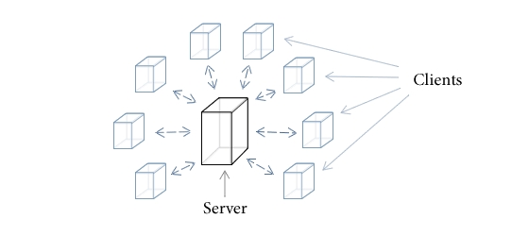

**Logical design**

There was need of coming up with a logical data model which contained all the needed logical and physical design choices and physical storage parameters needed to generate a design in a Data Definition Language, which was then used to create a database.

Logical design pertains to an abstract representation of the data flows, inputs and outputs of the system. This was often conducted via modeling, which involved a simplistic and sometimes graphical representation of an actual system. In the context of systems design, modeling could undertake the following forms, including:

* **a) Entity Relationship Diagrams**
* **b) Data flow diagrams**

### 

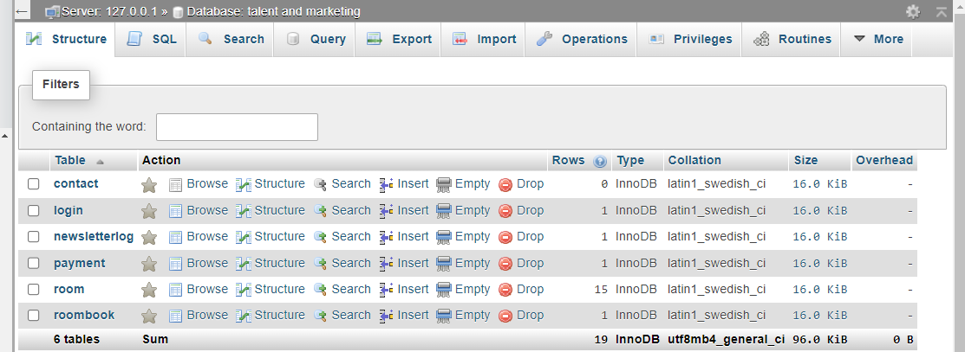

## **3.4 Implementation / Development**

### **3.4.1 Language(s), Frameworks and Other Technical Requirements**

This chapter is a description of the activities that ware carried out during the development of the system. During this phase the results of the design phase ware taken and the system was built accordingly. Code modules, interfaces and database tables were created and successfully integrated.

### **3.4.2 Code Review Strategy**

**Hardware interface requirements**

Processor speed of 0.5Ghz or more mobile gadgets.

Processor of speed 1.5ghz or more for desktop and computer gadgets.

Ram of 500mb and above for all the devices

Free storage memory capacity of more than 100mb.

**Software requirement interface**

Windows/android/Linux/max/chrome or any other OS.

Mozilla Firefox/chrome google/opera mini/uc browser or internet explorer.

### 

**Design architecture**

* • Presentation Layer for front end (js,css project).
* • WebAPI Layer for handle API calls
* • Application Layer
* • Business Layer for handle business related functions
* • Domain Layer for handle domain objects
* • Infrastructure Layer for handle and calls stored procedure
* • SP_DataAccess Layer for handle common db configuration

**INDEX.PHP**

<?php

include('db.php');

?> <!DOCTYPE html> <html lang="en"> <head> <title>ONLINE TALENT EXPRESSIONS

AND MAKETING SYSTEM</title>

<!-- for-mobile-apps -->

<meta name="viewport" content="width=device-width, initial-scale=1">

<meta http-equiv="Content-Type" content="text/html; charset=utf-8" />

<meta name="keywords" content="Resort Inn Responsive , Smartphone Compatible web template , Samsung, LG, Sony Ericsson, Motorola web design" />

<script type="application/x-javascript"> addEventListener("load", function() { setTimeout(hideURLbar, 0); }, false);

function hideURLbar(){ window.scrollTo(0,1); } </script>

<!-- //for-mobile-apps -->

<link href="css/bootstrap.css" rel="stylesheet" type="text/css" media="all" />

<link href="css/font-awesome.css" rel="stylesheet">

<link rel="stylesheet" href="css/chocolat.css" type="text/css" media="screen">

<link href="css/easy-responsive-tabs.css" rel='stylesheet' type='text/css'/>

<link rel="stylesheet" href="css/flexslider.css" type="text/css" media="screen" property="" />

<link rel="stylesheet" href="css/jquery-ui.css" />

<link href="css/style.css" rel="stylesheet" type="text/css" media="all" />

<script type="text/javascript" src="js/modernizr-2.6.2.min.js"></script>

<!--fonts-->

<link href="//fonts.googleapis.com/css?family=Oswald:300,400,700" rel="stylesheet">

<link href="//fonts.googleapis.com/css?family=Federo" rel="stylesheet">

<link href="//fonts.googleapis.com/css?family=Lato:300,400,700,900" rel="stylesheet">

<!--//fonts-->

</head>

<body>

<!-- header -->

<div class="banner-top">

<div class="social-bnr-agileits">

<ul class="social-icons3">

<li><a href="https://www.facebook.com/" class="fa fa-facebook icon-border facebook"> </a></li>

<li><a href="https://twitter.com/" class="fa fa-twitter icon-border twitter"> </a></li>

<li><a href="https://plus.google.com/u/0/" class="fa fa-google-plus icon-border googleplus"> </a></li>

</ul>

</div>

<div class="contact-bnr-w3-agile">

<ul>

<li><i class="fa fa-envelope" aria-hidden="true"></i><a href="mailto:info@example.com">KARANJAFIDELIS@ZETECH.AC.KE</a></li>

<li><i class="fa fa-phone" aria-hidden="true"></i>+254 702142046</li>

<li class="s-bar">

<div class="search">

<input class="search_box" type="checkbox" id="search_box">

<label class="icon-search" for="search_box"><span class="glyphicon glyphicon-search" aria-hidden="true"></span></label>

<div class="search_form">

<form action="#" method="post">

<input type="search" name="Search" placeholder=" " required=" " />

<input type="submit" value="Search">

</form>

</div>

</div>

</li>

</ul>

</div>

<div class="clearfix"></div>

</div>

<div class="w3_navigation">

<div class="container">

<nav class="navbar navbar-default">

<div class="navbar-header navbar-left">

<button type="button" class="navbar-toggle collapsed" data-toggle="collapse" data-target="#bs-example-navbar-collapse-1">

<span class="sr-only">Toggle navigation</span>

<span class="icon-bar"></span>

<span class="icon-bar"></span>

<span class="icon-bar"></span>

</button>

<h1><a class="navbar-brand" href="index.php">ONLINE TALENT EXPRESSION <span>AND MARKETING SYSTEM</span><p class="logo_w3l_agile_caption"> Marketing system for creative composers</p></a></h1>

</div>

<!-- Collect the nav links, forms, and other content for toggling -->

<div class="collapse navbar-collapse navbar-right" id="bs-example-navbar-collapse-1">

<nav class="menu menu--iris">

<ul class="nav navbar-nav menu__list">

<li class="menu__item menu__item--current"><a href="" class="menu__link">Home</a></li>

<li class="menu__item"><a href="#about" class="menu__link scroll">About</a></li>

<li class="menu__item"><a href="#team" class="menu__link scroll">Team</a></li>

<li class="menu__item"><a href="#gallery" class="menu__link scroll">Gallery</a></li>

<li class="menu__item"><a href="#contact" class="menu__link scroll">Contact</a></li>

</ul>

</nav>

</div>

</nav>

</div>

</div>

<!-- //header -->

<!-- banner -->

<div id="home" class="w3ls-banner">

<!-- banner-text -->

<div class="slider">

<div class="callbacks_container">

<ul class="rslides callbacks callbacks1" id="slider4">

<li>

<div class="container">

<div class="agileits-banner-info" style="background-image: url('images/optimist.jpeg'); color: White;">

<h4> LEARDERSHIP/ENTREPRENEUR</h4>

<h3>We offer enterpreneurship skills and young market business skills</h3>

<p>Really Good Remote Leaders do These 3 Things Daily</p>

1. Effectively giving constructive feedback virtually.

Perhaps Zoom fatigue is to blame, or maybe leaders are afraid of creating additional stress for their people. But whatever the reason, employees are not getting enough constructive feedback on their work.

"Feedback is a catalyst for growth," continued Jaramillo. "Without it, someone will never be able to reach their full potential."

Feedback conversations carry a lot of nuances, so the higher fidelity the communication channel, the less likely a miscommunication will happen. So when it comes to giving feedback virtually, Jaramillo says a video call is the way to go.

Being able to read facial expressions and other non-verbal signals is helpful in making sure the feedback lands as intended. If Zoom fatigue is what's holding you back, consider turning off your "self-view." Many people find that the most draining aspect of video calls isn't watching the other person, but their own face. We're simply not wired to monitor ourselves in a virtual mirror for hours at a time.

<div class="agileits_w3layouts_more menu__item">

<a href="#" class="menu__link" data-toggle="modal" data-target="#myModal">Learn More</a>

</div>

</div>

</div>

</div>

</li>

<li>

<div class="container">

<div class="agileits-banner-info" style="background-image: url('images/fashion.jpeg'); color: White;">

<h4>FASHION</h4>

<h3>This is a fashion</h3>

<p>young kids got fshon skills</p>

<div class="agileits_w3layouts_more menu__item">

<a href="#" class="menu__link" data-toggle="modal" data-target="#myModal">Learn More</a>

</div>

</div>

</div>

</div>

</li>

<li>

<div class="container">

<div class="agileits-banner-info" style="background-image: url('images/poet.jpeg'); color: White;">

<h4>POET</h4>

<h3>mindset for the future</h3>

<p>we value you</p>

<div class="agileits_w3layouts_more menu__item">

<a href="#" class="menu__link" data-toggle="modal" data-target="#myModal">Learn More</a>

</div>

</div>

</div>

</div>

</li>

</ul>

</div>

<div class="clearfix"> </div>

<!--banner Slider starts Here-->

</div>

<div class="thim-click-to-bottom">

<a href="#about" class="scroll">

<i class="fa fa-long-arrow-down" aria-hidden="true"></i>

</a>

</div>

</div>

<!-- //banner -->

<!--//Header-->

<!-- //Modal1 -->

<div class="modal fade" id="myModal" tabindex="-1" role="dialog">

<!-- Modal1 -->

<div class="modal-dialog">

<!-- Modal content-->

<div class="modal-content">

<div class="modal-header">

<button type="button" class="close" data-dismiss="modal">&times;</button>

<h4>ONLINE TALENT EXPRESSION <span>AND MARKETING SYSTEM</span></h4>

<img src="images/1.jpg" alt=" " class="img-responsive">

<h5>We know what you love</h5>

<p>The Future of Work Is Now: Your Role Has Changed</p>

</div>

</div>

</div>

</div>

<!-- //Modal1 -->

<div id="availability-agileits">

<div class="col-md-12 book-form-left-w3layouts">

<a href="admin/reservation.php"><h2>TALENT EXPRESSION</h2></a>

</div>

<div class="clearfix"> </div>

</div>

<!-- banner-bottom -->

<div class="banner-bottom">

<div class="container">

<div class="agileits_banner_bottom">

<h3><span>Offers marketing strategies</span> Finding out creative composures and talent</h3>

</div>

<div class="w3ls_banner_bottom_grids">

<ul class="cbp-ig-grid">

<li>

<div class="w3_grid_effect">

<span class="cbp-ig-icon w3_road"></span>

<h4 class="cbp-ig-title">FASHION NISTAS</h4>

<span class="cbp-ig-category">FASHION NOVA</span>

</div>

</li>

<li>

<div class="w3_grid_effect">

<span class="cbp-ig-icon w3_cube"></span>

<h4 class="cbp-ig-title">POETRY</h4>

<span class="cbp-ig-category">POET</span>

</div>

</li>

<li>

<div class="w3_grid_effect">

<span class="cbp-ig-icon w3_users"></span>

<h4 class="cbp-ig-title">GYMNASTIC</h4>

<span class="cbp-ig-category">FITNES</span>

</div>

</li>

<li>

<div class="w3_grid_effect">

<span class="cbp-ig-icon w3_ticket"></span>

<h4 class="cbp-ig-title">LEADERSHIP</h4>

<span class="cbp-ig-category">LEADING</span>

</div>

</li>

</ul>

</div>

</div>

</div>

<!-- //banner-bottom -->

<!-- /about -->

<div class="about-wthree" id="about">

<div class="container">

<div class="ab-w3l-spa">

<h3 class="title-w3-agileits title-black-wthree">About Fidelis online talent expression and maketing system</h3>

<p class="about-para-w3ls">really offer the best talent show and an oppotunity for youths </p>

<img src="images/1.jpg" class="img-responsive" alt="Composures">

<div class="w3l-slider-img">

<img src="images/2.jpeg" class="img-responsive" alt="Creative Composures">

</div>

<div class="w3ls-info-about">

<h4>We value creative composures</h4>

<p>Utapendezwa na wasanii wetu na sanaa mbalimbali! </p>

</div>

</div>

<div class="clearfix"> </div>

</div>

</div>

<!-- //about -->

<!--sevices-->

<div class="advantages">

<div class="container">

<div class="advantages-main">

<h3 class="title-w3-agileits">Our Services</h3>

<div class="advantage-bottom">

<div class="col-md-6 advantage-grid left-w3ls wow bounceInLeft" data-wow-delay="0.3s">

<div class="advantage-block ">

<i class="fa fa-credit-card" aria-hidden="true"></i>

<h4>ENTREPRENEURSHIP/TALENTS</h4>

<p>USIWE NA WASIWASI WOWOTE.</p>

<p><i class="fa fa-check" aria-hidden="true"></i>Leadership and maketing strategies</p>

<p><i class="fa fa-check" aria-hidden="true"></i>we market talent expression for professional individuals</p>

</div>

</div>

<div class="col-md-6 advantage-grid right-w3ls wow zoomIn" data-wow-delay="0.3s">

<div class="advantage-block">

<i class="fa fa-clock-o" aria-hidden="true"></i>

<h4>24 Hour operating</h4>

<p>USIWE NA WASIWASI WOWOTE</p>

<p><i class="fa fa-check" aria-hidden="true"></i>marketing service</p>

<p><i class="fa fa-check" aria-hidden="true"></i>24-hour Concierge service</p>

</div>

</div>

<div class="clearfix"> </div>

</div>

</div>

</div>

</div>

<!--//sevices-->

<!-- team -->

<div class="team" id="team">

<div class="container">

<h3 class="title-w3-agileits title-black-wthree">Meet Our Team</h3>

<div id="horizontalTab">

<ul class="resp-tabs-list">

<li>

<img src="images/optimist.jpeg" alt=" " class="img-responsive" />

</li>

<li>

<img src="images/poet.jpeg" alt=" " class="img-responsive" />

</li>

<li>

<img src="images/Leadership.jpg" alt=" " class="img-responsive" />

</li>

<li>

<img src="images/inspiration.jpg" alt=" " class="img-responsive" />

</li>

</ul>

<div class="resp-tabs-container">

<div class="tab1">

</div>

<div class="social-bnr-agileits footer-icons-agileinfo">

<ul class="social-icons3">

<li><a href="#" class="fa fa-facebook icon-border facebook"> </a></li>

<li><a href="#" class="fa fa-twitter icon-border twitter"> </a></li>

<li><a href="#" class="fa fa-google-plus icon-border googleplus"> </a></li>

<li><a href="#" class="fa fa-rss icon-border rss"> </a></li>

</ul>

</div>

<div class="clearfix"> </div>

<h4>Fidelis Karanja</h4>

<span>Manager</span>

</div>

</div>

<div class="clearfix"> </div>

</div>

<div class="tab2">

</div>

<h4>Sarah</h4>

<span>Receptionist</span>

<div class="clearfix"> </div>

</div>

</div>

</div>

<!-- //team -->

<!-- Gallery -->

<section class="portfolio-w3ls" id="gallery">

<h3 class="title-w3-agileits title-black-wthree">Our Gallery</h3>

<div class="col-md-3 gallery-grid gallery1">

<a href="images/g1.jpg" class="swipebox"><img src="images/poet.jpEg" class="img-responsive" alt="/">

<div class="textbox">

<h4>POET</h4>

<p><i class="fa fa-picture-o" aria-hidden="true"></i></p>

</div>

</a>

</div>

<div class="col-md-3 gallery-grid gallery1">

<a href="images/g2.jpg" class="swipebox"><img src="images/leadership.jpg" class="img-responsive" alt="/">

<div class="textbox">

<h4>LEADERSHIP</h4>

<p><i class="fa fa-picture-o" aria-hidden="true"></i></p>

</div>

</a>

</div>

<div class="col-md-3 gallery-grid gallery1">

<a href="images/g3.jpg" class="swipebox"><img src="images/entertreneur.jpg" class="img-responsive" alt="/">

<div class="textbox">

<h4>ENTREPRENEUR</h4>

<p><i class="fa fa-picture-o" aria-hidden="true"></i></p>

</div>

</a>

</div>

<div class="col-md-3 gallery-grid gallery1">

<a href="images/g4.jpg" class="swipebox"><img src="images/optimist.jpeg" class="img-responsive" alt="">

<div class="textbox">

<h4>OPTIMIST</h4>

<p><i class="fa fa-picture-o" aria-hidden="true"></i></p>

</div>

</a>

</div>

<div class="col-md-3 gallery-grid gallery1">

<a href="images/g5.jpg" class="swipebox"><img src="images/gym.jpeg" class="img-responsive" alt="/">

<div class="textbox">

<h4>GYMNASTIC</h4>

<p><i class="fa fa-picture-o" aria-hidden="true"></i></p>

</div>

</a>

</div>

<div class="col-md-3 gallery-grid gallery1">

<a href="images/g6.jpg" class="swipebox"><img src="images/recreation.jpeg" class="img-responsive" alt="/">

<div class="textbox">

<h4>RECREATION</h4>

<p><i class="fa fa-picture-o" aria-hidden="true"></i></p>

</div>

</a>

</div>

<div class="col-md-3 gallery-grid gallery1">

<a href="images/g6.jpg" class="swipebox"><img src="images/fashion.jpeg" class="img-responsive" alt="/">

<div class="textbox">

<h4>FASHION</h4>

<p><i class="fa fa-picture-o" aria-hidden="true"></i></p>

</div>

</a>

</div>

<div class="col-md-3 gallery-grid gallery1">

<a href="images/g6.jpg" class="swipebox"><img src="images/humility.jpeg" class="img-responsive" alt="/">

<div class="textbox">

<h4>HUMILITY</h4>

<p><i class="fa fa-picture-o" aria-hidden="true"></i></p>

</div>

</a>

</div>

<div class="col-md-3 gallery-grid gallery1">

<a href="images/g9.jpg" class="swipebox"><img src="images/IMG_OO22.jpeg" class="img-responsive" alt="/">

<div class="textbox">

<h4>TEACHER</h4>

<p><i class="fa fa-picture-o" aria-hidden="true"></i></p>

</div>

</a>

<div class="clearfix"> </div>

</section>

<!-- //gallery -->

<!-- rooms & rates -->

<div class="plans-section" id="rooms">

<div class="container">

<h3 class="title-w3-agileits title-black-wthree">Talents and Expressions</h3>

<div class="priceing-table-main">

<div class="col-md-3 price-grid">

<div class="price-block agile">

<div class="price-gd-top">

<img src="images/IMG_0022.jpeg" alt=" " class="img-responsive" />

<h4>teacher</h4>

</div>

<div class="price-gd-bottom">

<div class="price-list">

<ul>

<li><i class="fa fa-star" aria-hidden="true"></i></li>

<li><i class="fa fa-star" aria-hidden="true"></i></li>

<li><i class="fa fa-star" aria-hidden="true"></i></li>

<li><i class="fa fa-star" aria-hidden="true"></i></li>

<li><i class="fa fa-star-o" aria-hidden="true"></i></li>

</ul>

</div>

<div class="price-selet">

<h3><span>kes</span>220</h3>

<a href="admin/reservation.php" >Book Now for lessons</a>

</div>

</div>

</div>

</div>

<div class="col-md-3 price-grid ">

<div class="price-block agile">

<div class="price-gd-top">

<img src="images/fashion.jpeg" alt=" " class="img-responsive" />

<h4>fashion</h4>

</div>

<div class="price-gd-bottom">

<div class="price-list">

<ul>

<li><i class="fa fa-star" aria-hidden="true"></i></li>

<li><i class="fa fa-star" aria-hidden="true"></i></li>

<li><i class="fa fa-star" aria-hidden="true"></i></li>

<li><i class="fa fa-star" aria-hidden="true"></i></li>

<li><i class="fa fa-star-o" aria-hidden="true"></i></li>

</ul>

</div>

<div class="price-selet">

<h3><span>kes</span>220</h3>

<a href="admin/reservation.php" >Book Now for fashion classes</a>

</div>

</div>

</div>

</div>

<div class="col-md-3 price-grid lost">

<div class="price-block agile">

<div class="price-gd-top">

<img src="images/feedback.jpeg" alt=" " class="img-responsive" />

<h4>Coucelling</h4>

</div>

<div class="price-gd-bottom">

<div class="price-list">

<ul>

<li><i class="fa fa-star" aria-hidden="true"></i></li>

<li><i class="fa fa-star" aria-hidden="true"></i></li>

<li><i class="fa fa-star" aria-hidden="true"></i></li>

<li><i class="fa fa-star-o" aria-hidden="true"></i></li>

<li><i class="fa fa-star-o" aria-hidden="true"></i></li>

</ul>

</div>

<div class="price-selet">

<h3><span>kes</span>180</h3>

<a href="admin/reservation.php" >Book Now for counsellation</a>

</div>

</div>

</div>

</div>

<div class="col-md-3 price-grid wthree lost">

<div class="price-block agile">

<div class="price-gd-top ">

<img src="images/recreation.jpeg" alt=" " class="img-responsive" />

<h4>recreational</h4>

</div>

<div class="price-gd-bottom">

<div class="price-list">

<ul>

<li><i class="fa fa-star" aria-hidden="true"></i></li>

<li><i class="fa fa-star" aria-hidden="true"></i></li>

<li><i class="fa fa-star-o" aria-hidden="true"></i></li>

<li><i class="fa fa-star-o" aria-hidden="true"></i></li>

<li><i class="fa fa-star-o" aria-hidden="true"></i></li>

</ul>

</div>

<div class="price-selet">

<h3><span>kes</span> 150</h3>

<a href="admin/reservation.php" >Book Now for recreation services</a>

</div>

</div>

</div>

</div>

<div class="clearfix"> </div>

</div>

</div>

</div>

<!--// rooms & rates -->

<!-- visitors -->

<div class="w3l-visitors-agile" >

<div class="container">

<h3 class="title-w3-agileits title-black-wthree">Book for services offered above</h3>

</div>

<div class="w3layouts_work_grids">

<section class="slider">

<div class="flexslider">

<ul class="slides">

<li>

<div class="w3layouts_work_grid_left">

<img src="images/5.jpg" alt=" " class="img-responsive" />

<div class="w3layouts_work_grid_left_pos">

<img src="images/entertreneur.jpg" alt=" " class="img-responsive" />

</div>

</div>

<div class="w3layouts_work_grid_right">

<h4>

<i class="fa fa-star" aria-hidden="true"></i>

<i class="fa fa-star" aria-hidden="true"></i>

<i class="fa fa-star" aria-hidden="true"></i>

<i class="fa fa-star" aria-hidden="true"></i>

<i class="fa fa-star" aria-hidden="true"></i>

</h4>

<p>Entrepreneur</p>

<h5>Juliet Anna</h5>

<p>Kenya</p>

</div>

<div class="clearfix"> </div>

</li>

<li>

<div class="w3layouts_work_grid_left">

<img src="images/2.jpeg" alt=" " class="img-responsive" />

<div class="w3layouts_work_grid_left_pos">

<img src="images/poet.jpeg" alt=" " class="img-responsive" />

</div>

</div>

<div class="w3layouts_work_grid_right">

<h4>

<i class="fa fa-star" aria-hidden="true"></i>

<i class="fa fa-star" aria-hidden="true"></i>

<i class="fa fa-star" aria-hidden="true"></i>

<i class="fa fa-star" aria-hidden="true"></i>

<i class="fa fa-star-o" aria-hidden="true"></i>

POET

</h4>

<p>Poet</p>

<h5>Jaden Kariuki</h5>

<p>kenya</p>

</div>

<div class="clearfix"> </div>

</li>

<li>

<div class="w3layouts_work_grid_left">

<img src="images/2.jpeg" alt=" " class="img-responsive" />

<div class="w3layouts_work_grid_left_pos">

<img src="images/fashion.jpeg" alt=" " class="img-responsive" />

</div>

</div>

<div class="w3layouts_work_grid_right">

<h4>

<i class="fa fa-star" aria-hidden="true"></i>

<i class="fa fa-star" aria-hidden="true"></i>

<i class="fa fa-star" aria-hidden="true"></i>

<i class="fa fa-star" aria-hidden="true"></i>

<i class="fa fa-star-o" aria-hidden="true"></i>

FASHION NOVA

</h4>

<p>S</p>

<h5>Rosalind Mweni</h5>

<p>Kenya</p>

</div>

<div class="clearfix"> </div>

</li>

<li>

<div class="w3layouts_work_grid_left">

<img src="images/2.jpeg" alt=" " class="img-responsive" />

<div class="w3layouts_work_grid_left_pos">

<img src="images/gym.jpeg" alt=" " class="img-responsive" />

</div>

</div>

<div class="w3layouts_work_grid_right">

<h4>

<i class="fa fa-star" aria-hidden="true"></i>

<i class="fa fa-star" aria-hidden="true"></i>

<i class="fa fa-star" aria-hidden="true"></i>

<i class="fa fa-star-o" aria-hidden="true"></i>

<i class="fa fa-star-o" aria-hidden="true"></i>

GYMNASTICS

</h4>

<p> </p>

<h5>Nyaboke Faith</h5>

<p>Kenya</p>

</div>

<div class="clearfix"> </div>

</li>

</ul>

</div>

</section>

</div>

</div>

<!-- visitors -->

<!-- contact -->

<section id="contact">

<div class="container">

<div class="col-lg-6 col-md-6 col-sm-6 contact-w3-agile2" data-aos="flip-left">

<div class="contact-agileits">

<h4>Contact Us</h4>

<p class="contact-agile2">Sign Up For Our News Letters</p>

<form method="post" name="sentMessage" id="contactForm" >

<div class="control-group form-group">

<label class="contact-p1">Full Name:</label>

<input type="text" class="form-control" name="name" id="name" required >

<p class="help-block"></p>

</div>

<div class="control-group form-group">

<label class="contact-p1">Phone Number:</label>

<input type="tel" class="form-control" name="phone" id="phone" required >

<p class="help-block"></p>

</div>

<div class="control-group form-group">

<label class="contact-p1">Email Address:</label>

<input type="email" class="form-control" name="email" id="email" required >

<p class="help-block"></p>

</div>

<input type="submit" name="sub" value="Send Now" class="btn btn-primary">

</form>

<?php

if(isset($_POST['sub']))

{

$name =$_POST['name'];

$phone = $_POST['phone'];

$email = $_POST['email'];

$approval = "Not Allowed";

$sql = "INSERT INTO `contact`(`fullname`, `phoneno`, `email`,`cdate`,`approval`) VALUES ('$name','$phone','$email',now(),'$approval')" ;

if(mysqli_query($con,$sql))

echo"OK";

}

?>

</div>

</div>

<div class="col-lg-6 col-md-6 col-sm-6 contact-w3-agile1" data-aos="flip-right">

<h4>Connect With Us</h4>

<p class="contact-agile1"><strong>Phone :</strong>+2547 02142046</p>

<p class="contact-agile1"><strong>Email :</strong> <a href="mailto:name@example.com">FIDELISKARANJA@ZETECH.AC.KE</a></p>

<p class="contact-agile1"><strong>Address :</strong> ZETECH UNIVERSITY RUIRU KAIMBU</p>

<div class="social-bnr-agileits footer-icons-agileinfo">

<ul class="social-icons3">

<li><a href="#" class="fa fa-facebook icon-border facebook"> </a></li>

<li><a href="#" class="fa fa-twitter icon-border twitter"> </a></li>

<li><a href="#" class="fa fa-google-plus icon-border googleplus"> </a></li>

</ul>

</div>

<iframe src="https://www.bing.com/maps?q=Zetech%20University&satid=id.sid%3A5d2db5c1-6b9d-1873-0232-dfa32250f91c" ></iframe>

</div>

<div class="clearfix"></div>

</div>

</section>

<!-- /contact -->

<div class="copy">

<p>© 2022 FIDELIS KARANJA . All Rights Reserved | Design by <a href="index.php">ONLINE TALENT EXPRESSION AND MARKETING SYSTEM</a> </p>

</div>

<!--/footer -->

<!-- js -->

<script type="text/javascript" src="js/jquery-2.1.4.min.js"></script>

<!-- contact form -->

<script src="js/jqBootstrapValidation.js"></script>

<!-- /contact form -->

<!-- Calendar -->

<script src="js/jquery-ui.js"></script>

<script>

$(function() {

$( "#datepicker,#datepicker1,#datepicker2,#datepicker3" ).datepicker();

});

</script>

<!-- //Calendar -->

<!-- gallery popup -->

<link rel="stylesheet" href="css/swipebox.css">

<script src="js/jquery.swipebox.min.js"></script>

<script type="text/javascript">

jQuery(function($) {

$(".swipebox").swipebox();

});

</script>

<!-- //gallery popup -->

<!-- start-smoth-scrolling -->

<script type="text/javascript" src="js/move-top.js"></script>

<script type="text/javascript" src="js/easing.js"></script>

<script type="text/javascript">

jQuery(document).ready(function($) {

$(".scroll").click(function(event){

event.preventDefault();

$('html,body').animate({scrollTop:$(this.hash).offset().top},1000);

});

});

</script>

<!-- start-smoth-scrolling -->

<!-- flexSlider -->

<script defer src="js/jquery.flexslider.js"></script>

<script type="text/javascript">

$(window).load(function(){

$('.flexslider').flexslider({

animation: "slide",

start: function(slider){

$('body').removeClass('loading');

}

});

});

</script>

<!-- //flexSlider -->

<script src="js/responsiveslides.min.js"></script>

<script>

// You can also use "$(window).load(function() {"

$(function () {

// Slideshow 4

$("#slider4").responsiveSlides({

auto: true,

pager:true,

nav:false,

speed: 500,

namespace: "callbacks",

before: function () {

$('.events').append("<li>before event fired.</li>");

},

after: function () {

$('.events').append("<li>after event fired.</li>");

}

});

});

</script>

<!--search-bar-->

<script src="js/main.js"></script>

<!--//search-bar-->

<!--tabs-->

<script src="js/easy-responsive-tabs.js"></script>

<script>

$(document).ready(function () {

$('#horizontalTab').easyResponsiveTabs({

type: 'default', //Types: default, vertical, accordion

width: 'auto', //auto or any width like 600px

fit: true, // 100% fit in a container

closed: 'accordion', // Start closed if in accordion view

activate: function(event) { // Callback function if tab is switched

var $tab = $(this);

var $info = $('#tabInfo');

var $name = $('span', $info);

$name.text($tab.text());

$info.show();

}

});

$('#verticalTab').easyResponsiveTabs({

type: 'vertical',

width: 'auto',

fit: true

});

});

</script>

<!--//tabs-->

<!-- smooth scrolling -->

<script type="text/javascript">

$(document).ready(function() {

/*

var defaults = {

containerID: 'toTop', // fading element id

containerHoverID: 'toTopHover', // fading element hover id

scrollSpeed: 1200,

easingType: 'linear'

};

*/

$().UItoTop({ easingType: 'easeOutQuart' });

});

</script>

<div class="arr-w3ls">

<a href="#home" id="toTop" style="display: block;"> <span id="toTopHover" style="opacity: 1;"> </span></a>

</div>

<!-- //smooth scrolling -->

<script type="text/javascript" src="js/bootstrap-3.1.1.min.js"></script>

</body>

</html>

## 

## **3.5 Testing**

### **3.5.1 Functional Requirements Testing**

The most important requirements are to provide end-user involvement, prototyping, change management, immediate response, risk minimization, no administrative overhead and transparency and guidance. Knowing the end users requirements is essential for the development of successful Online Talent Expression and Marketing System. Defining the main goals for the development of a Online Talent Expression And Marketing System.

**Testing requirement analysis**

REVIEW

IMPLEMENT

DESIGN

ANALYSIS

### **3.5.2 Non-Functional Requirements Testing**

**Interactive and good performance**

The website for an Online Talent Expression And Marketing system shall have the following abilities and capabilities.

* Responsiveness of the website shall be high and the website shall behave as per the user action.
* The response time and throughput time on the site shall be minimal.
* Consistency on the website shall be maintained across all the web pages
* The user shall be acknowledged in the form of visual changes and feedback on the site to enhance the interaction.

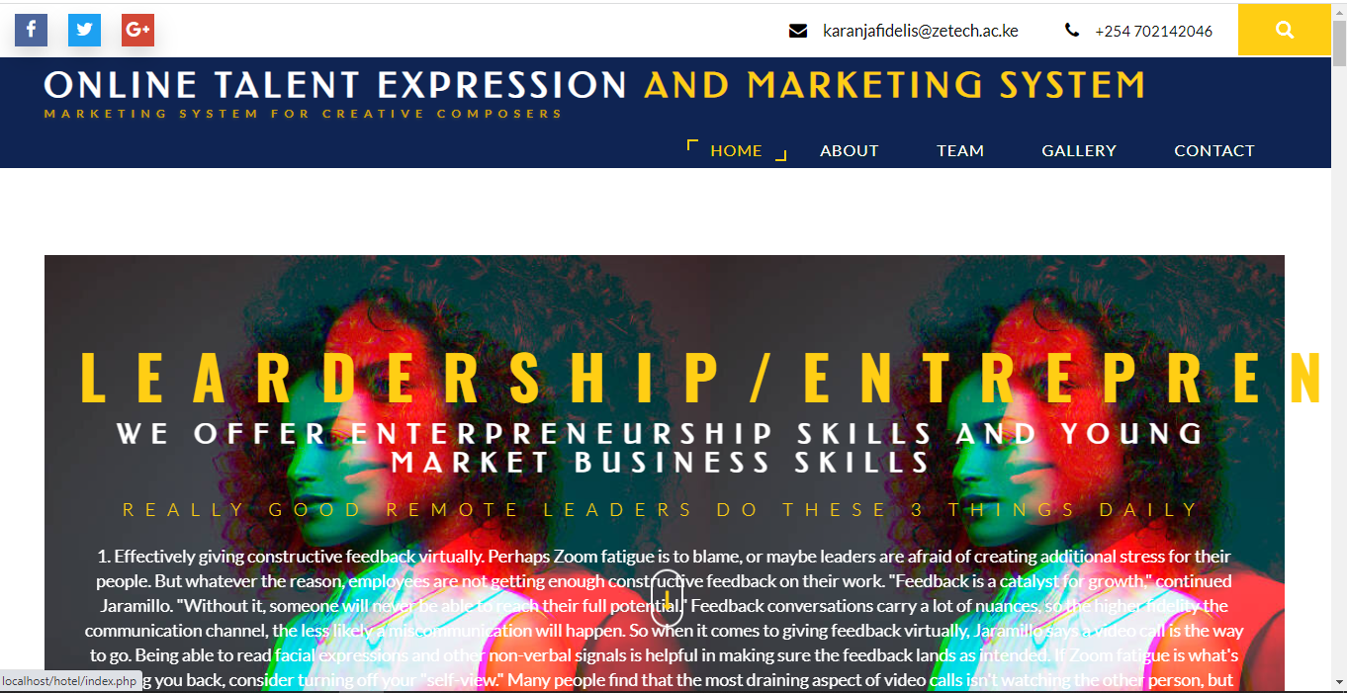

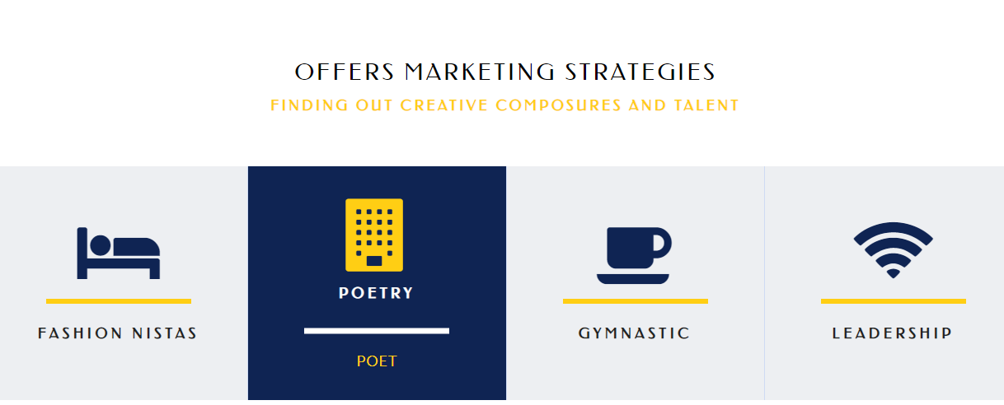



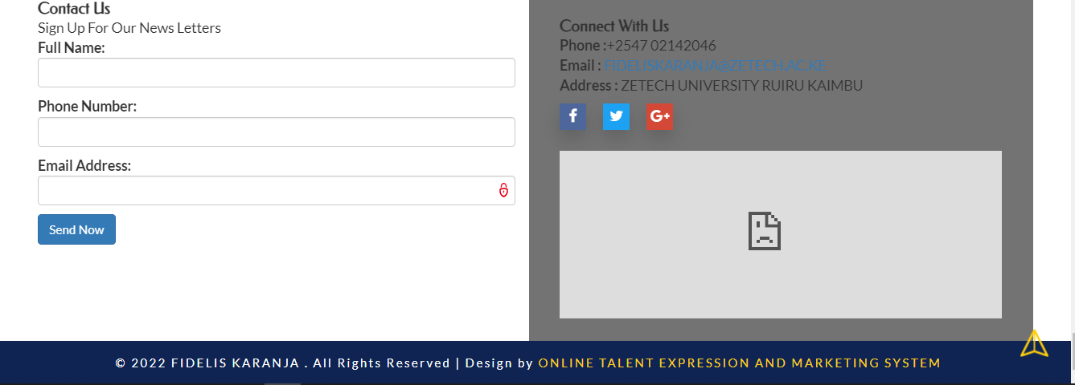

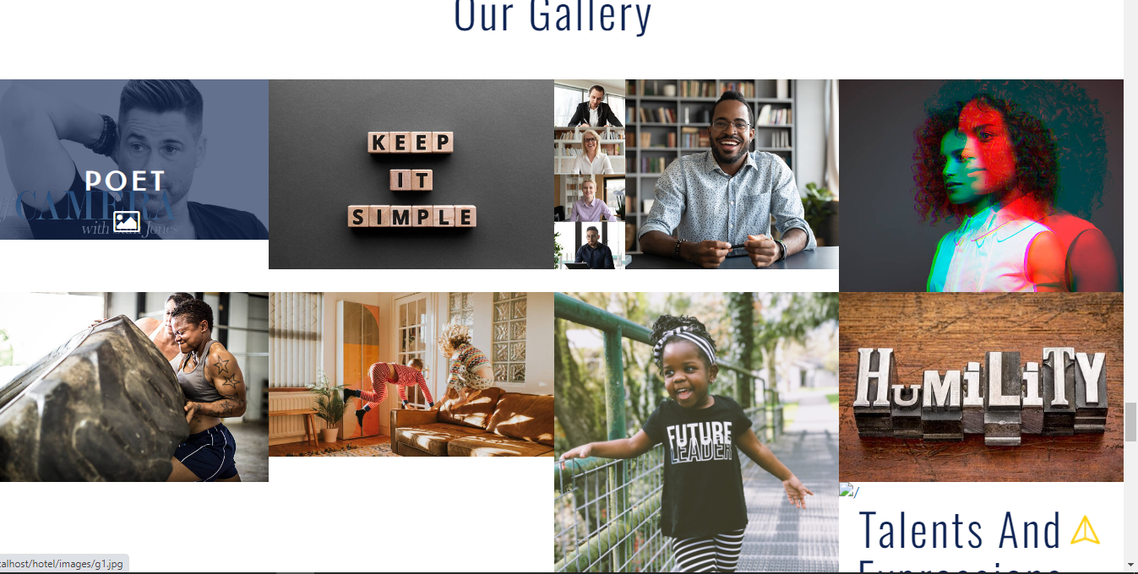

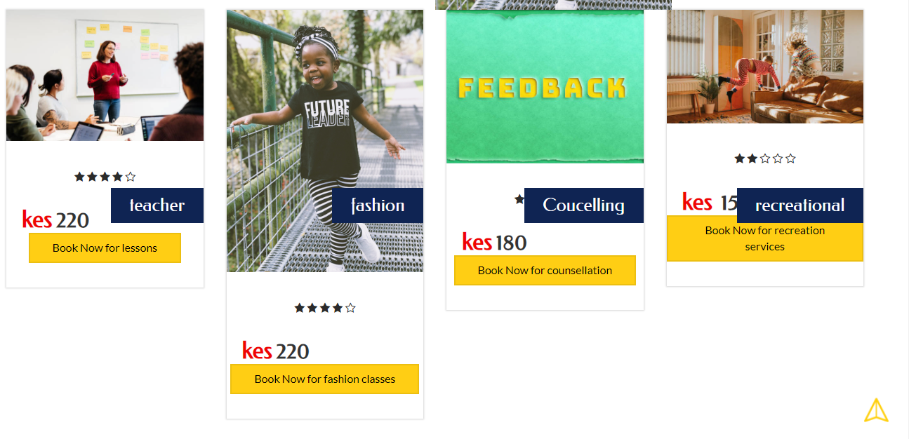

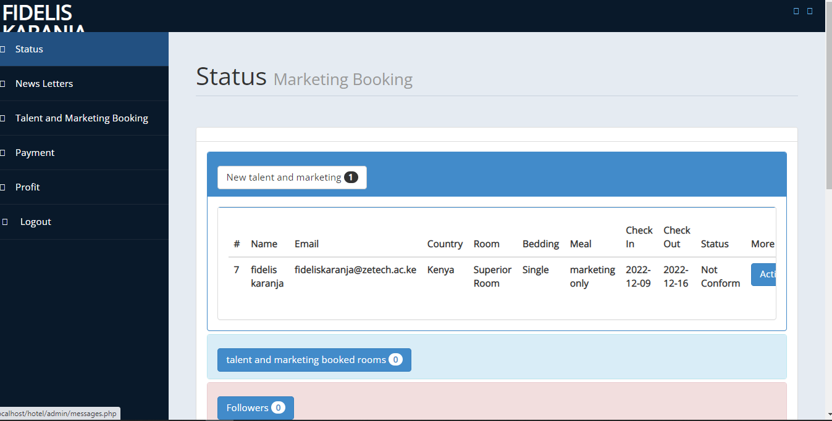

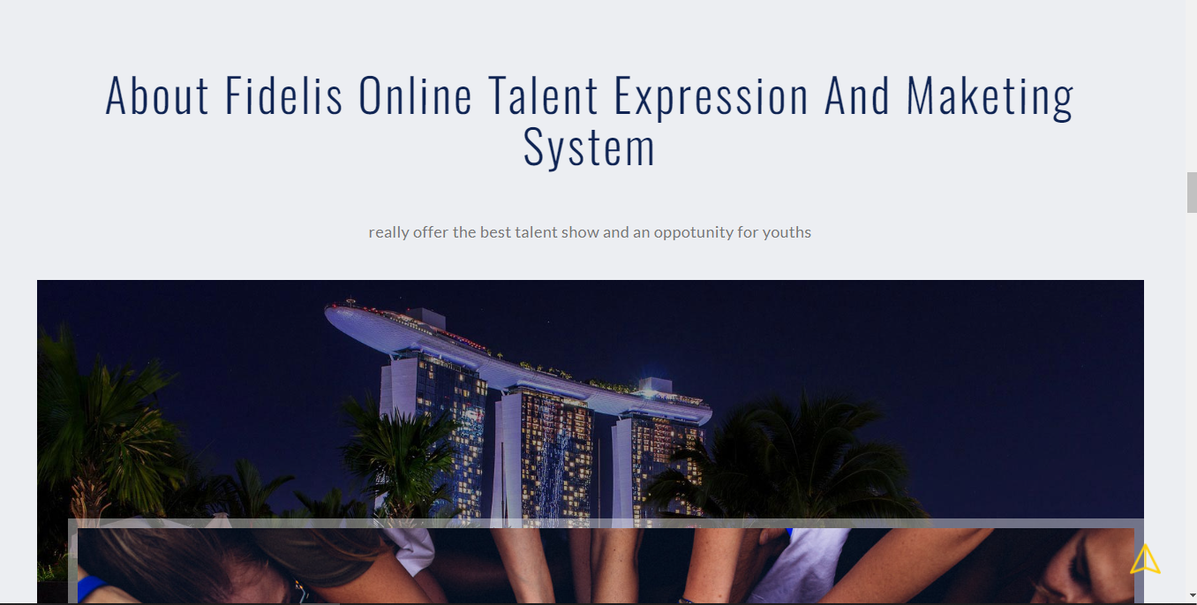

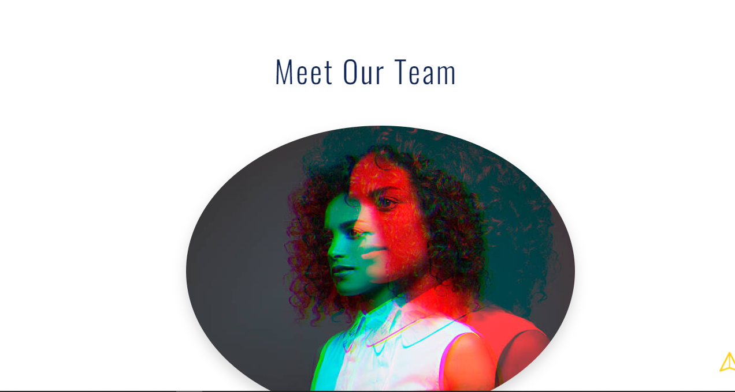

# **CHAPTER FOUR: CONCLUSION AND RECOMMENDATIONS**

## **4.1 CONCLUSION**

As a result, the Online Talent Expression and Marketing system enables the kids and users to save their information in an easily accessible manner on the internet. It is also saved in a format that is both efficient and retrievable.

This system will allow both the user as the kid and the admin to have access to the website at any time and from any location.

Thus, while storing the facts in a web-based Talent Expression and Marketing software system, reliability, availability, confidentiality, and maintainability are achieved.

## **4.2 RECOMMENDATIONS**

In the current circumstances, as a result of the proliferation of viruses and the escalating number of crises, the number of users seeking for Online Talent Expression and Marketing platform is also expanding. It is nearly impossible to keep the application’s track of each borrower manually in such a case.

This system may also be expanded up to serve a large number of people and family globally, enhancing the system's profit and usage as well as the ability to work in a simple and straightforward manner using the system's user-friendly interface.

***Adding following future enhancement in the system are as follows.***

1. Create attractive separate web sites for each disabled kid using data collect in current version.

2. Enhance the features of the system

**CHAPTER FIVE: REFERENCES AND APPENDICES**

## **5.1 REFERENCES**

[1] Wikipedia. “Requirements analysis” Internet:

http://en.wikipedia.org/wiki/Requirements_analysis [May 14 2017]

[2] Accurate iOneSoft (Pvt.) Ltd. “JustBookSalon”. Internet:

http://amazon.com [May 10 2017]

[3] Tyner Blain. “Ten Requirements Gathering Techniques”. Internet:

http://tynerblain.com/blog/2006/11/21/ten-requirements-gathering-techniques/

[May 21 2017]

[4] PCMag Digital Group. “Definition of: Web application”. Internet:

http://www.pcmag.com/encyclopedia/term/54272/web-application[May 28

2017]

[5] Wikipedia. “Use Case Diagram”. Internet:

http://en.wikipedia.org/wiki/Use_Case_Diagram [June 06 2017]

[6] Wikipedia. “Class Diagram”. Internet:

http://en.wikipedia.org/wiki/Class_diagram [June 10 2017]

[7] Wikipedia. “Activity Diagaram”. Internet:

http://en.wikipedia.org/wiki/Activity_diagra[June 10 2017]

[8] Wikipedia. “Entity Relationship Diagram”. Internet:

http://en.wikipedia.org/wiki/Entity%E2%80%93relationship_model [June 16

2017]

[10] Tutorials Point. “Angular 2”. Internet: